Medical Certificate for severe allergic reaction
Severe allergic reaction to: Palm Oil
Medical certificate issued to: Minister of Consumer Affairs
Patients name:
Severe Irritation caused by: |  | (Please tick)
Underpaid workers
Deforestation
Human rights abuses
Death of wildlife
Carbon emissions
The patient requires the following government policy change:
“Palm oil labelling to be mandatory on all products that contain it, within a time frame that is fair on companies yet still reflects the urgency of the issue.”
Patient signature: | Date:
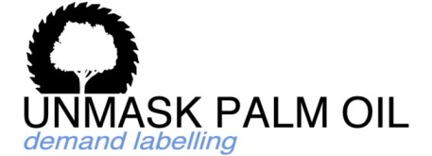
Find us on:

